Objective Questions

- Are there any tables with duplicate or missing null values? If so, how would you handle them?

Ans: I checked all the 7 tables for duplicate and missing/null values. No duplicate and missing/null values were found, indicating that the dataset is clean.
Query:

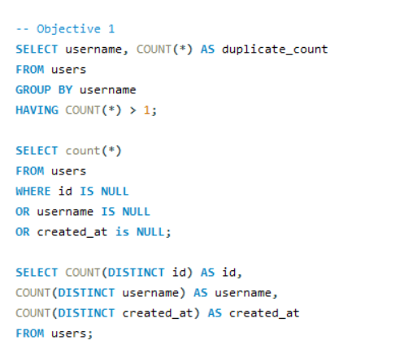
Output:
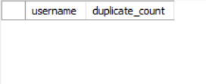

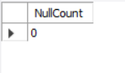

Although no missing/null values or duplicate records were found, if found the following steps would be taken:
- Remove duplicate records.
- Delete rows containing missing or null values where necessary.
- Replace the null columns with appropriate substitutes such as:
  - 'NA' for categorical/ text fields,
  - 0 for numerical fields,
  - or the average (mean) value in the case of numerical field.

- What is the distribution of user activity levels (e.g., number of posts, likes, comments) across the user base?

Ans:
Query:
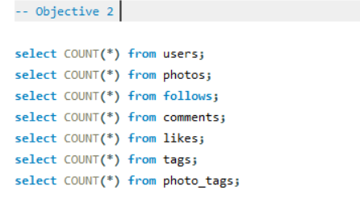

Users | 100
Posts | 257
Likes | 8782
Comments | 7488
Tags | 21
Tagged Photos | 501
Follows | 7623
Visualization:

The distribution of user activity levels across the user base is as follows-
There are 100 users, 257 photos, 8782 likes, 21 tags/tag names used by users, 501 photos tagged, 7623 follows and 7488 comments.

- Calculate the average number of tags per post (photo_tags and photos tables).

Ans: The average number of tags per post is 2.6368

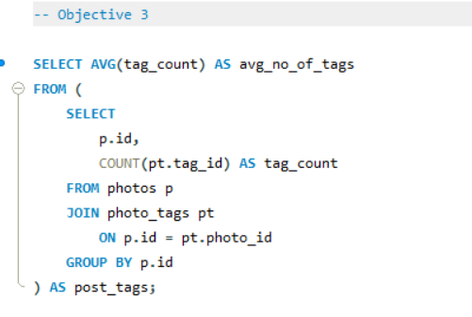

Output:
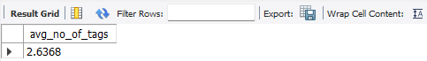

- Identify the top users with the highest engagement rates (likes, comments) on their posts and rank them.

Ans: Engagement Rate = $\frac{Total Engagements (Total_likes+Total_comments)}{Number of Followers}$ X 100

Using the above formula top 10 users with the highest engagement rates are identified.

Query:
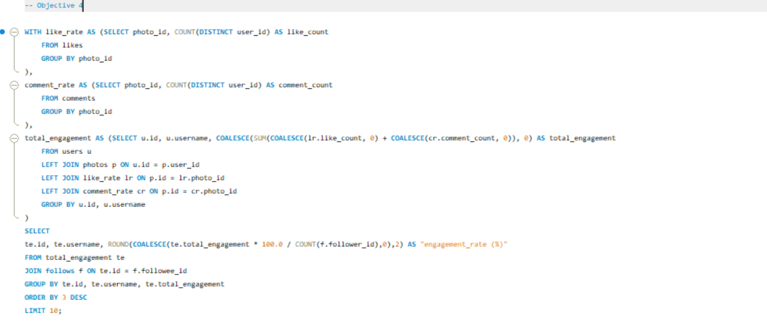

Output:
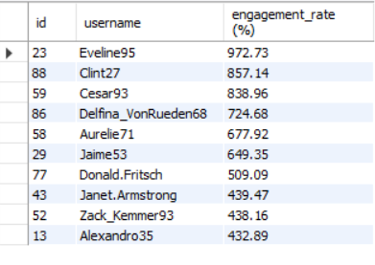

- Which users have the highest number of followers and followings?

Ans: Aurelie71, Bartholome.Bernhard, Cesar93 and 20 other users have the highest number of
followers with a count of 77 followers.

Query:
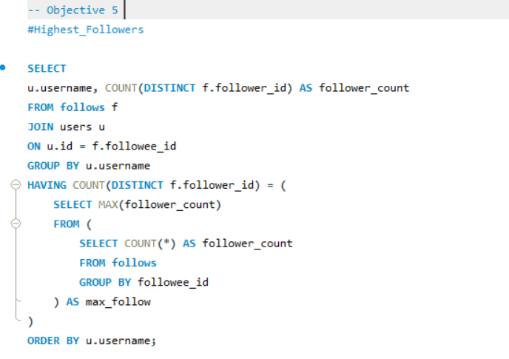

Output:
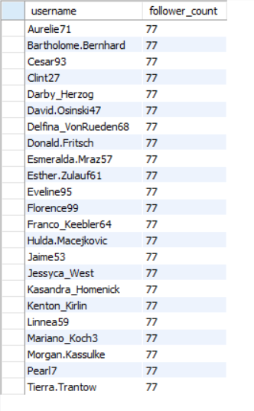

Adelle96, Aiyana_Hoeger, Alek_Watsica and 74 other users have the highest number of following with a following count of 99.

Query:
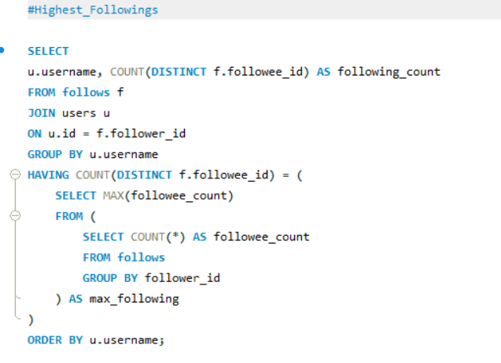

Output:

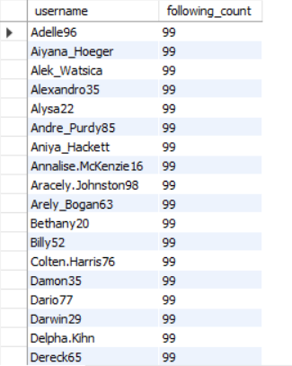

- Calculate the average engagement rate (likes, comments) per post for each user.

Ans: The average engagement rate per post for each user-

Query:

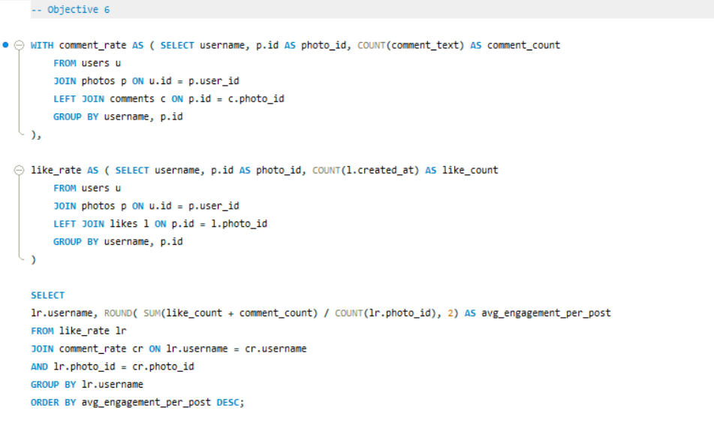

Output:

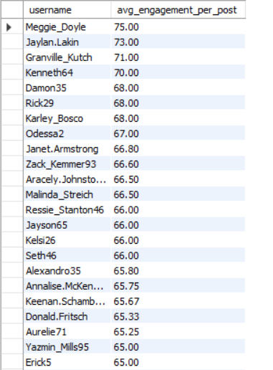

- Get the list of users who have never liked any post (users and likes tables)

Ans: There are total 23 users who never like any post. Here is the list-

Query:
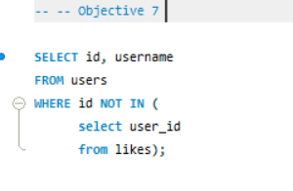

Output:
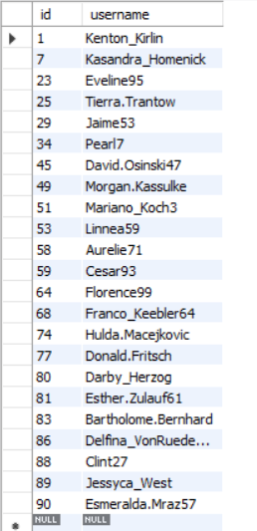

- How can you leverage user-generated content (posts, hashtags, photo tags) to create more personalized and engaging ad campaigns?

Ans: The data provided in the users, photos, follows, comments, likes, tags and photo_tags tables can be used to gain insights into user trends and interests. Hence, we can leverage user-generated content (posts, hashtags, photo tags) to create more personalized and engaging ad campaigns.

Reference -1:
Query:

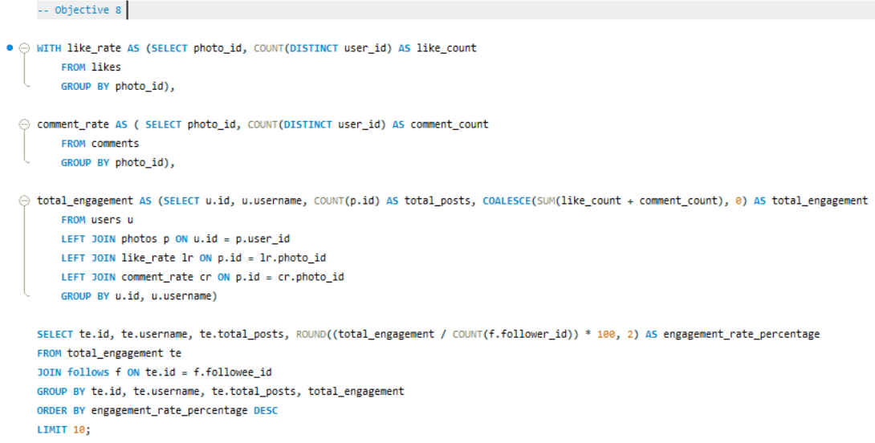

Output:
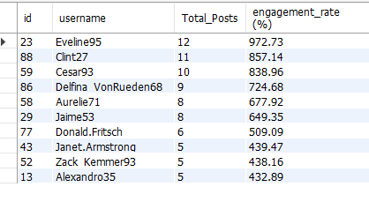

Visualization:

Reference-2:
Query:

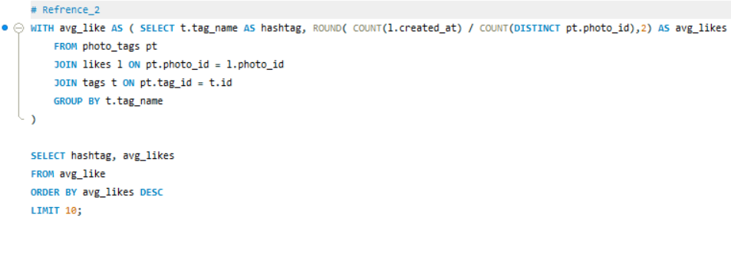

Output:
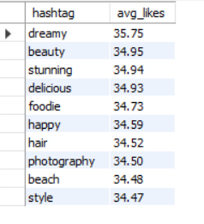

Visualization:

By utilizing the data from the above references, we can create hyper-targeted ad campaigns based on the following:

- User interests (derived from photos and tags)
- Engagement (likes and comments)
- Influence (followers and followed)
- User behaviour (encouraging non-engagers to participate)
- Personalized ad strategies (based on engagement rate)

- Are there any correlations between user activity levels and specific content types (e.g., photos, videos, reels)? How can this information guide content creation and curation strategies?
Ans:
The dataset lacks distinct attributes for specific content formats like videos, reels, or stories. Therefore, the analysis relied on accessible user activity metrics specifically total posts, likes, comments, and average engagement given that every post in the dataset consists of images.

The analysis suggests a positive correlation between user activity levels and engagement. Observations indicate that as the number of posts rises, the aggregate count of likes and comments also tends to grow. This suggests that users who post more often tend to generate greater audience interaction and engagement.

By examining user activity levels and engagement patterns, organizations can uncover key insights to inform their content creation and curation strategies.

Focus on developing content formats and themes that drive greater engagement to enhance audience interaction.

Consistently posting content, especially when done by active users, tends to generate more likes and comments, indicating that a regular schedule can boost visibility and engagement.

Engagement analysis can reveal user preferences, enabling the development of personalized content strategies that align with audience interests.

By consistently tracking engagement metrics, businesses and content creators can refine and optimize their future content strategies in response to audience feedback.

Nevertheless, the existing dataset encompasses only photographic posts, excluding other media formats like videos or reels. Consequently, the existing dataset was insufficient to conduct a thorough examination of how engagement levels relate to various content formats.

Query:

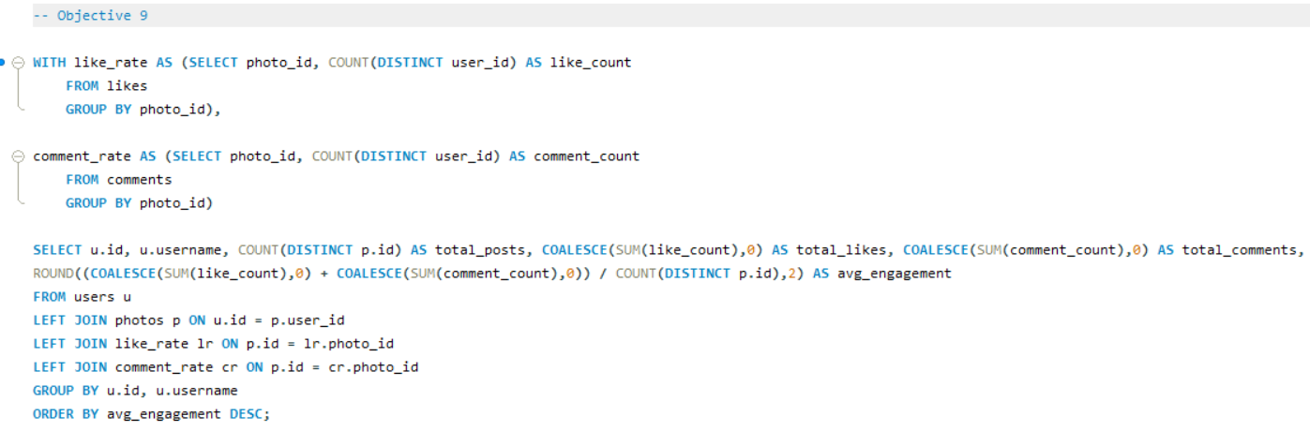

Output:

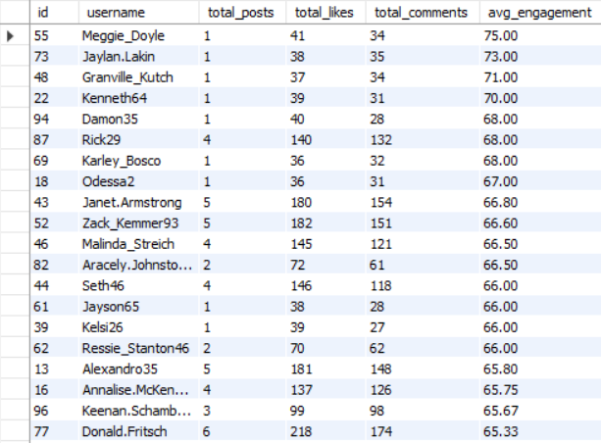

- Calculate the total number of likes, comments, and photo tags for each user.

Ans: Total number of likes, comments, and photo tags for each user has been calculated below-
Query:

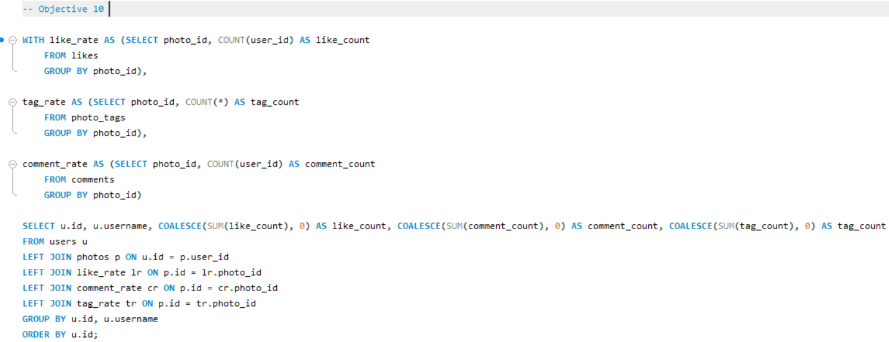

Output:
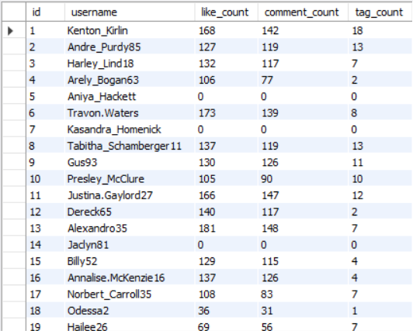

- Rank users based on their total engagement (likes, comments, shares) over a month.

Ans: Based on total engagement “Eveline95” has the rank 1 & so on.

Query:

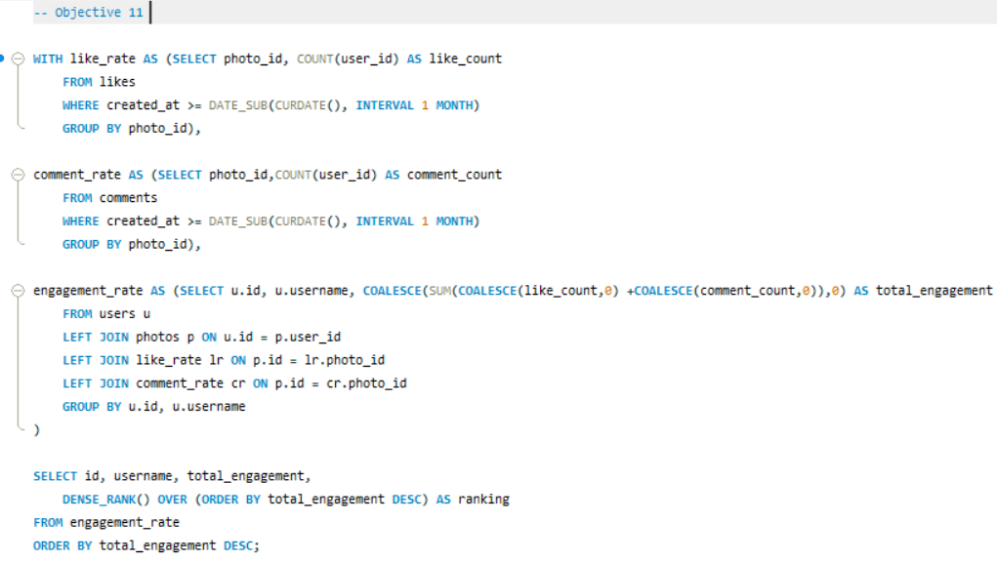

Note- Since the dataset does not contain a separate “shares” table, the user ranking analysis was performed based on the available engagement metrics likes and comments.

Output:
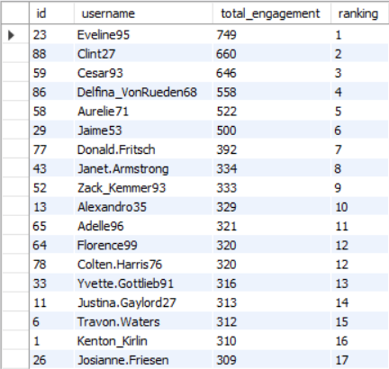

- Retrieve the hashtags that have been used in posts with the highest average number of likes. Use a CTE to calculate the average likes for each hashtag first.

Ans: The hashtag ‘dreamy’ has been used in posts with the highest average number of likes.
Query:

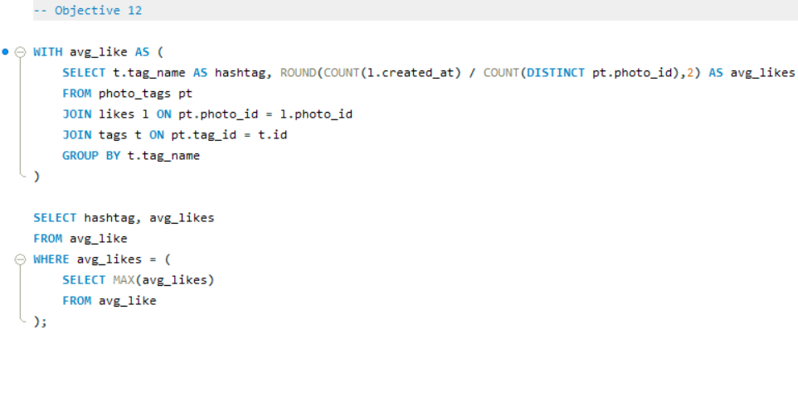

Output:

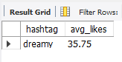

- Retrieve the users who have started following someone after being followed by that person.
Ans:
Query:
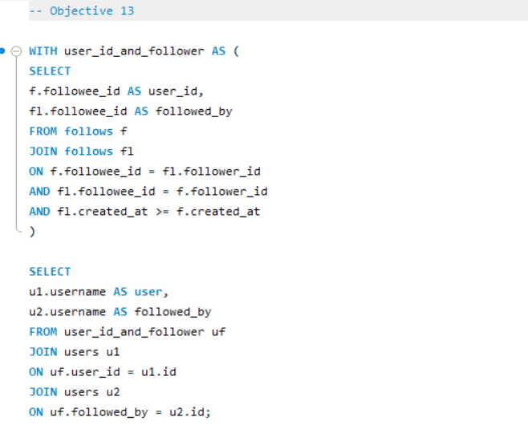
Output:
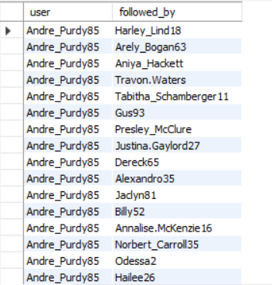

Subjective Questions

- Based on user engagement and activity levels, which users would you consider the most loyal or valuable? How would you reward or incentivize these users?

Ans:
Approach: Based on the Engagement Rate & Total uploaded posts Top 10 users have been found to be the most loyal & valuable for the business.

Query:

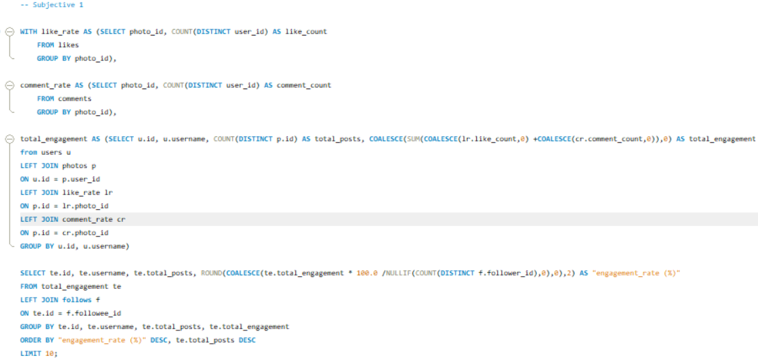

Output: The list of the top 10 users are below in the output.

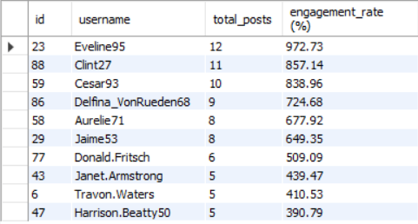

The top users can be rewarded in following ways-
- Exclusive Features: Provide early access to new features, such as filters or analytics tools.
- Badges: Assign loyalty badges to their profiles enhancing social status.
- Discounts or Partnerships: Offer discounts on sponsored products or partner with them for exclusive deals.
- Recognition: Highlight top users in community announcements or create "Top User" leaderboards.

- For inactive users, what strategies would you recommend to re-engage them and encourage them to start posting or engaging again?

Ans:
Approach: The users with minimal engagements & Posts are identified as the Inactive Users.
Here the users with 0 Total Posts and 0 Engagements (likes, comments) considered as Inactive users.

Query:

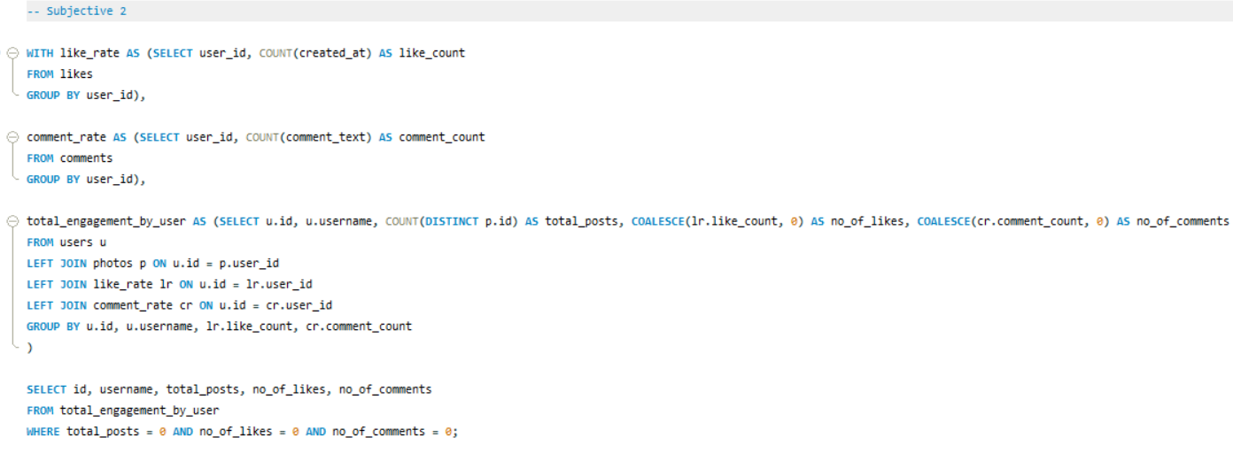

Output: The list of the Inactive users is below in the output.

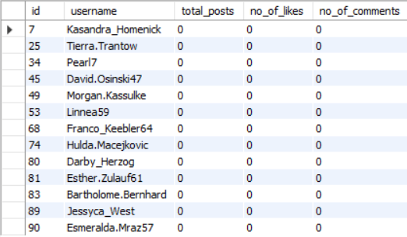

The following strategies could be suggested for inactive users
- Send notifications about friends’ recent activities or anniversaries of their account creation.
- Introduce daily engagement challenges or streak rewards to encourage regular activity.
- Offer discounts, free features to try, or additional storage for becoming active again.
- Engage users through surveys to understand why they became inactive and address their concerns.

- Which hashtags or content topics have the highest engagement rates? How can this information guide content strategy and ad campaigns?
Ans:
Approach: The hashtags with the highest engagement rates can be identified by filtering out top 5 hashtags in terms of highest average likes & comments. This can further give insights for content strategy and ad campaigns.

Query:

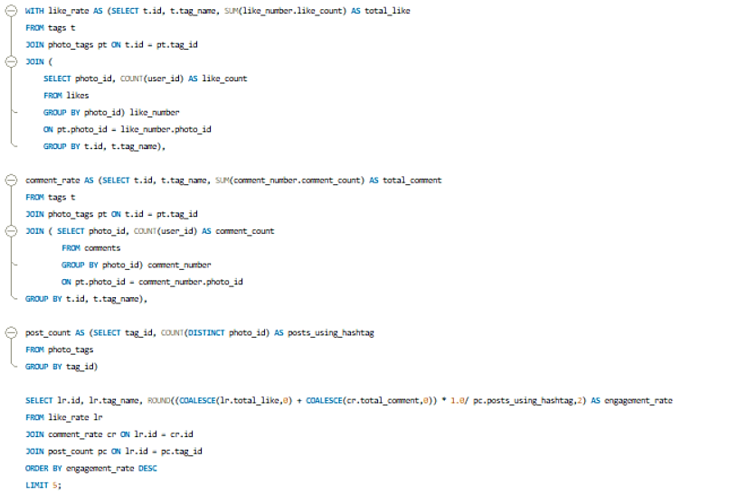

Output: The following 5 hashtags have the highest engagement rates – delicious, beauty, foodie, sunset, stunning.

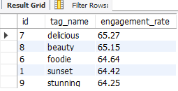

We can focus content around these hashtags to boost visibility of the targeted content and ads. Furthermore, development of ad campaigns targeting these hashtags to maximize reach and interaction can also be helpful.

- Are there any patterns or trends in user engagement based on demographics (age, location, gender) or posting times? How can these insights inform targeted marketing campaigns?
Ans:
Approach:
While the provided schema lacks demographic data, trends can still be analysed based on posting times. Engagement trends across times can be calculated by grouping likes or comments by hour(created_at).

Query:

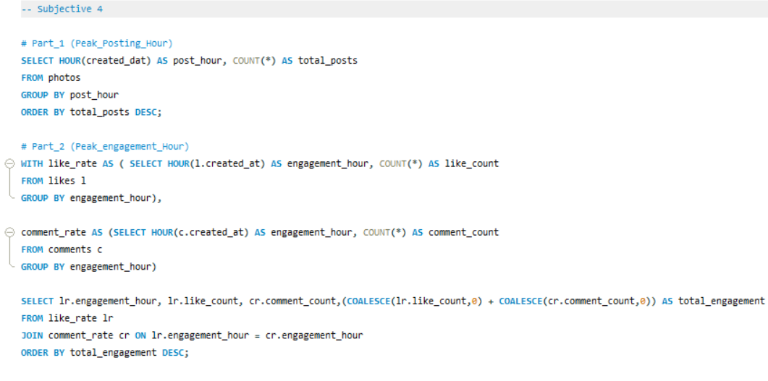

Output:

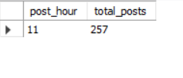

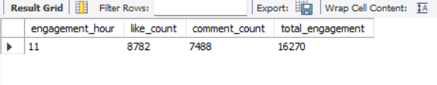

As per the analysis, most posts are created around 12 noon. Further analysis showed that the highest user engagement occurred during the 11 AM hour, with 8,782 likes and 7,488 comments, resulting in a total engagement of 16,270 interactions.

These insights suggest that targeted marketing campaigns, advertisements, and content posting should be scheduled around late morning to noon hours to maximize audience engagement and visibility.

- Based on follower counts and engagement rates, which users would be ideal candidates for influencer marketing campaigns? How would you approach and collaborate with these influencers?
Ans:
Approach:
The ideal users are those with highest follower counts and engagement rate. A combination of these metrics determines their influence. Hence, we can order them based on these metrics and select top 10.

Query:

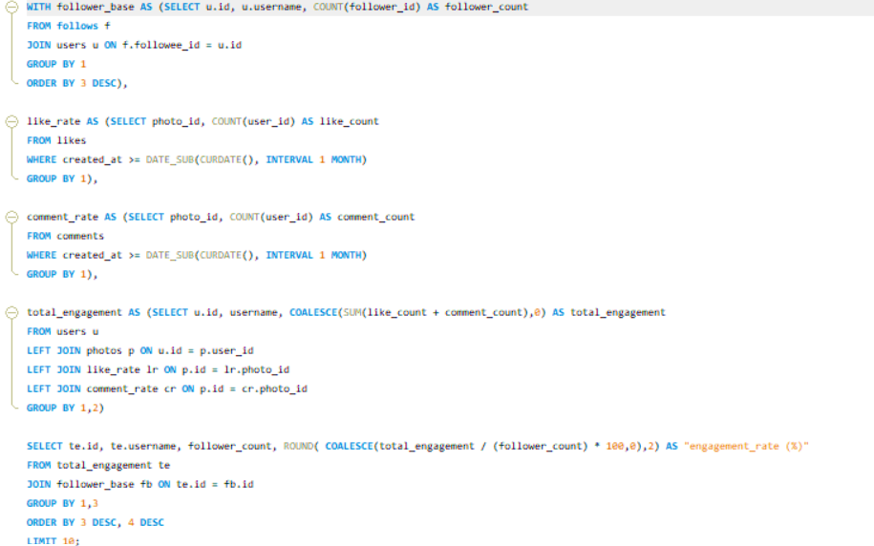

Output: These Top 10 users would be ideal candidates for influencer marketing campaigns.

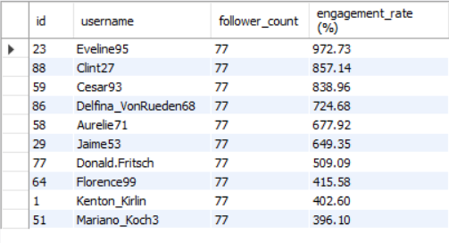
We can collaborate with these users in the following ways –
- Collaborate with these users for product endorsements.
- Offer exclusive partnerships or profit-sharing models.
- Collaborate to create content that promotes certain products.
- Collaborate for various shows for promotion.

- Based on user behaviour and engagement data, how would you segment the user base for targeted marketing campaigns or personalized recommendations?

Ans:
Users can be segmented based on their behaviour, activity levels, and engagement patterns. This segmentation helps in designing personalized marketing campaigns, improving user retention, and enhancing recommendation systems.

User Segments
• Engaged Users- Engaged users exhibit a high volume of likes, comments, and posts, indicating consistent interaction with platform content. These users are ideal candidates for personalized recommendations, premium features, and promotional campaigns because they actively contribute to the platform ecosystem.

• Influencers- Influencers are users with a large follower base and high engagement rates on their posts. These users are suitable for influencer marketing campaigns, sponsored collaborations, and brand partnerships due to their strong audience reach and influence.

• Passive Engagers- These users frequently like and comment on content but rarely create posts themselves. They can be targeted with trending content recommendations, creator suggestions, and interactive campaigns to increase their platform activity.

• Inactive Users- Inactive users have minimal or no engagement in terms of posts, likes, or comments. Re-engagement strategies such as personalized notifications, email campaigns, feature updates, and promotional offers can help bring them back to the platform.

Query:

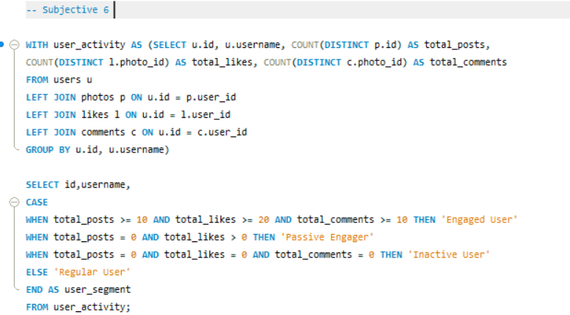

Output:

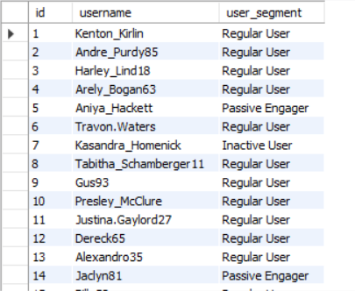

- If data on ad campaigns (impressions, clicks, conversions) is available, how would you measure their effectiveness and optimize future campaigns?

Approach: Assuming I have a table called ad_campaigns with the following columns: campaign_id, impressions, clicks, conversions, cost, revenue, campaign_date

Query: Here's an SQL query to calculate these metrics for each campaign:

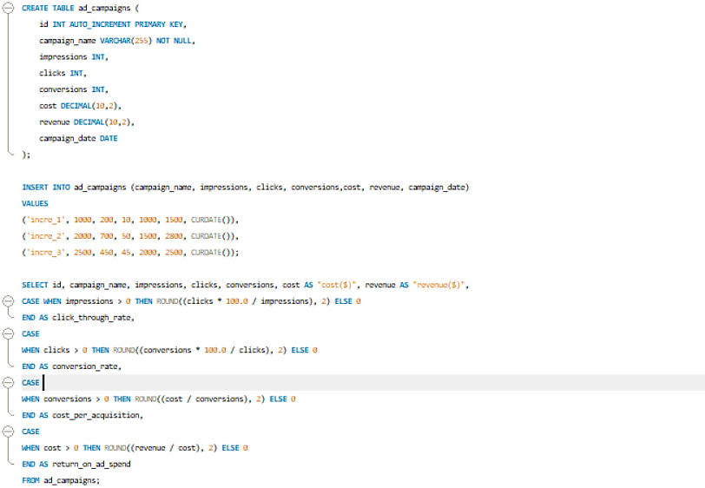

Output:

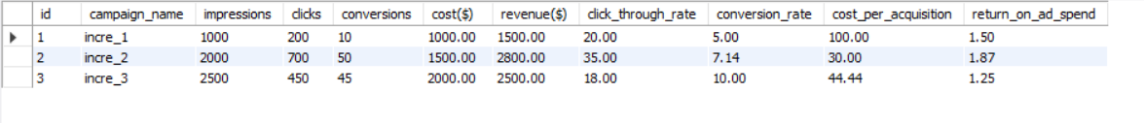

Explanation:
- CTR (Click-Through Rate): This is calculated by dividing the number of clicks by the number of impressions and then multiplying by 100. It shows how well an ad is making people click on it. A higher CTR means the ad is more interesting and relevant to the people seeing it.

- Conversion Rate: This is calculated by dividing the number of conversions by the number of clicks and then multiplying by 100. It shows how well clicks are turning into actions like buying something, signing up, downloading, or subscribing. A higher conversion rate means the ad and website are working well together.

- CPA (Cost Per Acquisition): This is calculated by dividing the total cost by the number of conversions. It tells you the average cost of getting one customer or conversion. A lower CPA means you're spending less to get more customers.

- ROAS (Return on Ad Spend): This is calculated by dividing the total revenue by the advertising cost. It shows how profitable your ad campaign is. If ROAS is above 1, your campaign is making money. If it's below 1, you may need to adjust your strategy.

Optimizing Future Campaigns:
- Improve CTR: Try different ad designs, images, headlines, and targeting to make your ads more appealing and get more clicks.
- Boost Conversion Rate: Make your landing pages better, improve your website or app experience, and use stronger calls to action to turn more clicks into real results.
- Lower CPA: Be more specific with who you're targeting, improve your bidding, test different ad versions, and focus on high-performing keywords or groups to reduce the cost of getting customers.
- Maximize ROAS: Spend more on campaigns that are performing well and cut back on those that aren’t. Keep checking how your campaigns are doing to make them even better.

Conclusion:
By keeping an eye on important ad metrics like CTR, Conversion Rate, CPA, and ROAS, businesses can see how well their campaigns are doing, find areas to improve, and plan better marketing strategies to increase engagement, conversions, and profits.

- How can you use user activity data to identify potential brand ambassadors or advocates who could help promote Instagram's initiatives or events?

Ans:
To identify potential brand ambassadors or advocates using user activity data on Instagram, we can examine various metrics that reflect their engagement and influence on the platform.

Key Metrics for Brand Ambassadors:

- Follower Count: Users with a large follower base, indicating they have reach and influence over others

- Engagement Rate: High activity levels in terms of likes, comments, and posts, demonstrating active participation.

- Content Creation: Users who post a large number of photos and actively use tags, indicating that they frequently share content.

- Interaction: Users who receive a high number of likes and comments on their posts, showing that others engage with their content.

Query:

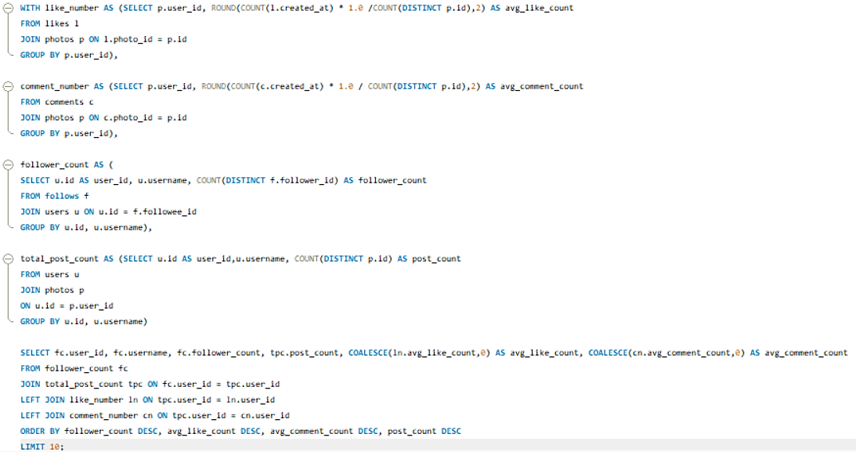

Output:

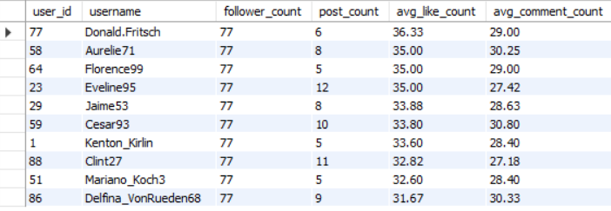

This query will create a list of top 10 potential brand ambassadors by looking at their engagement metrics, such as follower count, number of posts, average likes and comments per photo, and recent activity. These users can be targeted to promote Instagram's initiatives or events because of their strong engagement and influence on the platform.

- How would you approach this problem, if the objective and subjective questions weren't given?

Ans:
If the objective and subjective questions weren't provided, I would use an exploratory data analysis (EDA) combined with a business-focused approach to uncover useful insights from the dataset.

- Data Health Check and Cleaning
The first step would be to understand the data's quality and structure.
Activities:
- Check for missing values and duplicate entries
- Remove any duplicate records
- Deal with missing data in a suitable way
- Ensure the data is consistent and accurate
- Confirm that the relationships between data fields are correct
This helps make sure the dataset is accurate and dependable for further work.

- Data Exploration
Next, I would look into the structure of the data and how different tables are connected to understand how users behave and interact with the platform.
Activities:
- Examine the features in each table
- Understand how tables relate to each other, such as: users, photos, likes, comments, follows & tags
- Use SQL queries to look for patterns in user engagement and activity trends
This helps me see how users are using the platform.

- Define Useful Metrics (KPIs)
After understanding the data, I would create important performance indicators to measure how active the platform is and how engaged the users are.

Important metrics:
- Engagement rate
- How often users post
- Number of followers
- Likes and comments per post
- User activity levels
- Times when users are most active
- Performance of hashtags
These measurements help in assessing how well the platform is doing and how users are behaving.

- Generate Insights
Using the KPIs I've identified, I would create business insights and suggestions that can be put into action.

Possible insights:
- Group users based on their activity and engagement
- Find out which users are very active and loyal
- Spot inactive users for possible re-engagement efforts
- Find out which content performs well and which hashtags are trending
- Identify potential influencers and brand ambassadors
- Study trends in user engagement and posting habits
These insights can support:
- Targeted marketing campaigns,
- personalized recommendations,
- collaborations with influencers,
- and strategies for platform growth.

Conclusion:
This organized way of analyzing the data helps in making decisions based on facts and helps find useful patterns, trends, and opportunities, even if there are no specific business questions to start with.

- Assuming there's a "User_Interactions" table tracking user engagements, how can you update the "Engagement_Type" column to change all instances of "Like" to "Heart" to align with Instagram's terminology?
Ans:
Approach:
Since the original Instagram dataset didn’t have a user_interactions table, I created a new table to store different types of user engagement activities such as likes, comments, and shares.

Steps followed:
Created the user_interactions table:
Used DDL (CREATE TABLE) statements to define the table structure with columns such as:
- interaction ID
- user ID
- photo ID
- engagement type
- interaction date

Inserted sample interaction data:
Used DML (INSERT INTO) statements to insert the table with example records containing values like "Like", "Comment", and "Share".

Updated engagement terminology:
Used a DML (UPDATE) statement to replace all entries of "Like" with "Heart" in the engagement_type column.

Validated the update:
Used a SELECT query to verify that all "Like" values were successfully updated to "Heart".

This approach demonstrates the use of:
- DDL operations for table creation,
- DML operations for inserting and updating data,
- and basic data validation techniques in SQL.

Query:
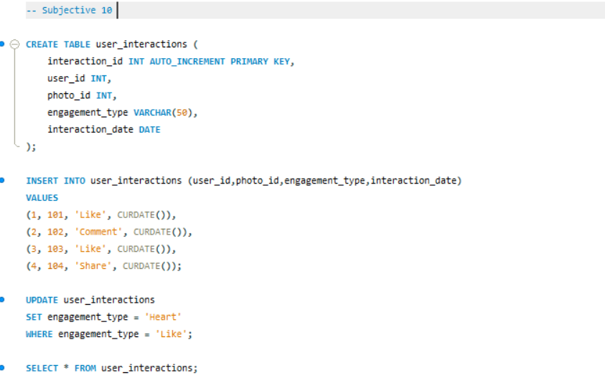
Output:

